Mid-autumn China

History:

The Mid-Autumn Festival (中秋节, Zhōngqiū Jié) dates back over 3,000 years to the Zhou Dynasty. It was originally a harvest festival celebrating the moon and giving thanks for the season's bounty. During the Tang (618–907) and Song (960–1279) dynasties, it became a more established festival with moon-viewing traditions, poetry, and family gatherings.

Meaning:

The festival symbolizes **family reunion, gratitude, and harmony**. The full moon represents unity, and people celebrate by gathering with loved ones, appreciating the moon, and offering prayers for happiness and prosperity.

Traditional:

Mooncakes (月饼, yuèbǐng): The most famous festival food, these round pastries symbolize unity and completeness.

Moon Gazing: Families and friends gather outdoors to admire the full moon.

Lantern Displays: Colorful lanterns are lit and released, symbolizing hope and good fortune.

Dragon and Lion Dances: Some regions hold performances to celebrate the occasion.

Worshiping the Moon Goddess Chang'e (嫦娥): Legends tell of Chang’e, who drank an elixir of immortality and now resides on the moon.

Galerry:

Ảnh có chứa phim hoạt hình, Phim hoạt hình, hình mẫu, Hoạt hình

Nội dung do AI tạo ra có thể không chính xác.

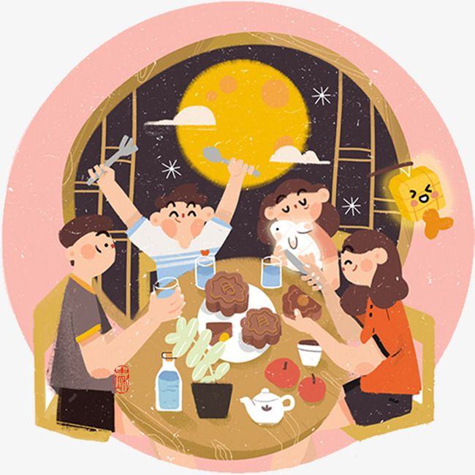Ảnh có chứa đèn lồng, hệ thống chiếu sáng, ánh sáng, Đèn lồng giấy

Nội dung do AI tạo ra có thể không chính xác.

Ảnh có chứa Tết âm lịch, Khiêu vũ, ngoài trời, lễ hội

Nội dung do AI tạo ra có thể không chính xác.